Testing Utility:

During testing we have developed a small utility that can be used in general purpose also.

As per the requirement of Nested Block Enhancement, the administrator should pre configure the Nested Block with pre defined XDATA to its Sub-Elements.

But manual process of attaching XDATA and particularly changing the XDATA is very laborious, error-prone and time consuming. Some times even to change a small thing, say to give a “-“ sign as prefix to some FID, one may have to delete the whole element and insert/draw a new element and attach all the other XDATA which was correctly attached to the earlier element.

For this we have developed a small AutoCAD VBA project (NS-AEC-IE XDATAMANAGER.dvb ) and an lisp file (NS-AEC-IE.LSP ). These two files have to be included into the Startup Suite as below.

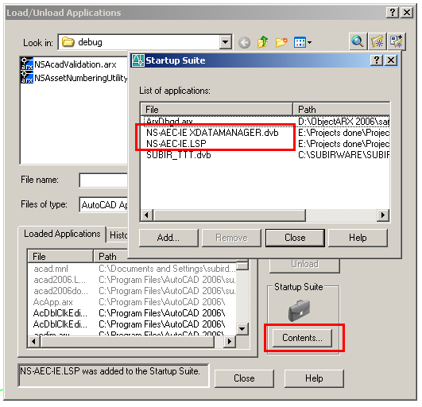

To attach/view/modify XDATA ( this application specific ) , the same tool is used.
To invoke the tool fire "XD” at the AutoCAD command prompt.

Then it will ask for selecting an entity. After valid selection the dialog box will pop-up as below.

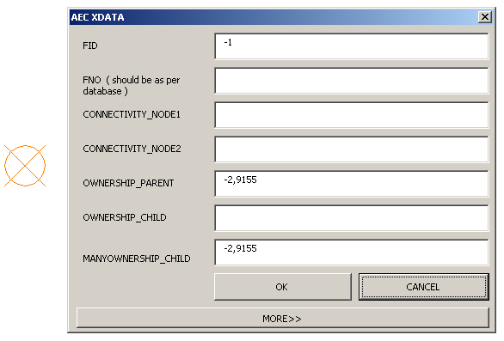

If the selected element does not have any FID, the corresponding textbox will be empty.

You can now attach new FID to the selected element by writing some number in the corresponding text box.

For new features , “-“ should be used as prefix. The FID value should be higher than 5000.

To aid this , if you double click on the label FID , it will fill the corresponding textbox with “-5000” which you can edit to suit you requirement , say you may change it to “-5003” .

This tool does not make any validation to the user input to this dialog. It goes as it is entered. So it’s the responsibility to the user/administrator to make correct entries in the text boxes.

It applies for the FNO too. The entry for FNO should be as per the standard access database . Other wise wrong/no data will be written into the exported XML.

The other 5 text box is setting connectivity & relationship. As per the requirement for nested blocks, the sub-features should have tags like <PNODE1> in CONNECTIVITY_NODE1 to refer to parent. Care should be taken so that proper tags is assigned to proper application name.

To aid this, one can double click on the label for the application name and the corresponding tag is automatically appended properly.

You don’t have to bother about “,” separator. The utility will take care of it properly.
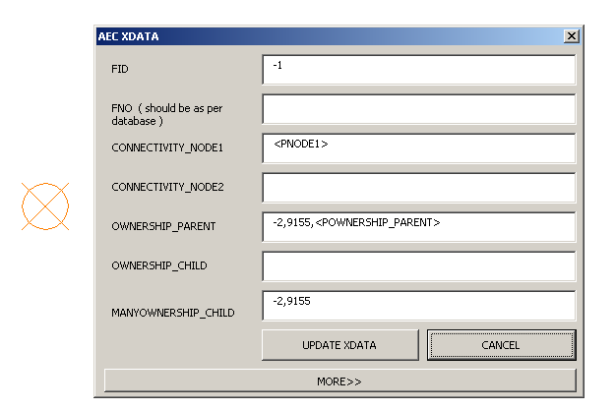

It’s important to notice that, whenever there is change in the textboxes, the caption “OK”
Changes to “UPDATE XDATA”.

To delete XDATA from an application , select the text in the corresponding textbox and select spacebar ( simply pressing delete or back space bar will not work – as it requires at least 1 space in the textbox before clicking “UPDATE DATA” ) .

When you invoke the dialog box the cancel button has the focus. So to dismiss the dialog simply press enter or even spacebar. This makes it easy to view the attached XDATA .

This tool has an extra feature. Sometimes you may want to find a particular object using its FID after getting some error message in the report.

To find some object by FID , click the “MORE>>” button and the dialog will expand as below.

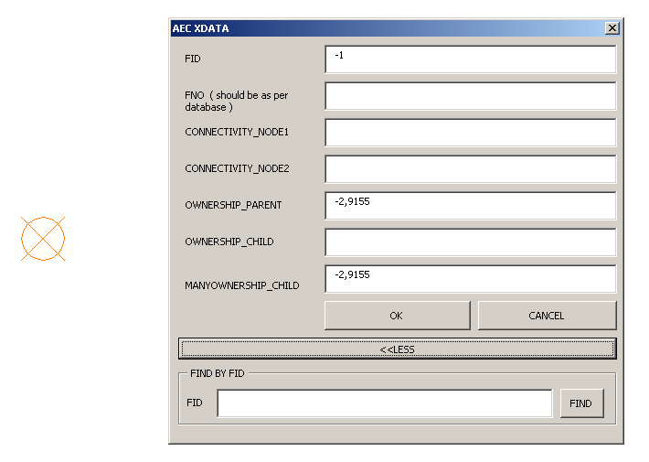
Just enter the FID you want to search and click/enter “FIND” button. It will find the object and fit it on the screen.

Additional function : The nested block will be made in such a way that user can’t explode it. But some times administrator may require to explode the nested block for some modification. But once a block is made to be unexplodable , its impossible to explode it or make it explodable.

To aid this , administrator may fire “XP” command which will invoke a dialog which will enable/disable the explodable property of a block.

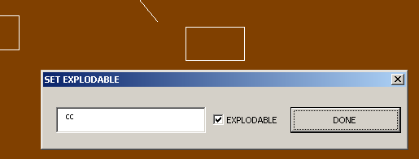

This tool asks for selecting a block reference , when selected successfully , the dialog pops up with the name of the block and its current explodable property set in the check box. Upon clicking the done button , the latest value of the checkbox will be used to set the explodable property of the block.

General assumptions for Nested Blocks:

- FID and FNO are mandatory XDATA for the child features of a nested feature.
- FID values should start with “-“ sign to denote new features. FID value should be high enough to maintain uniqueness of the FIDs. As a suggestion it should be more than 5000 however it may depend upon the number of features on the drawing.
- If FID of sub-feature is not set , its parent FID will not be replaced in the connectivity / relationship of the nearby features.
- Attributes of Sub-features of nested feature will be inherited from parent only ( nested feature ) and thus it will not look into DefaultAttributes table if the required value is set to 2 . In such case the attribute will not be exported to the XML.
- If sub-blocks don’t have <PASSET_NUM[N]> tags in the ASSET_NUM attribute , its value will not be changed.
- If sub-blocks don’t have the ASSET_NUM attribute , it will simply inherit the same value of ASSET_NUM as of its parent.
- If ASSET_NUM[N] attribute is not present in the parent ( nested block ), then the <PASSET_NUM[N]> tags will not be replaced in the ASSET_NUM attribute of the sub blocks.
- To treat a block as nested feature , it should be set to IsNestedFeature in the BlockFeatures table. For this a new column is to be added in the BlockFeatures table a below.

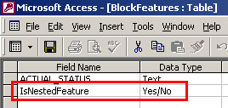

- To satisfy the “Pole on Existing layer” requirement , a new Error No is introduced and its Error Severity should be set to P4.

fldErrorNo | fldErrorSeverity | fldErrorCategory | fldErrorDescription
217 | P4 | Remaining GIS errors | Block B$ found on invalid layer, please verify attributes. IE Standard Layer =SL$, Current Layer = L$
Dynamic Block : To satisfy the relationship , even though the geometries of blocks are apart , dynamic block is used . Relationship is established with dynamic blocks as their insertion points are with in range though their visible geometries are at distance.

However it had some side effect. Some ammoniums blocks with names like *U21 etc. were appearing in the error reports and relationship were also not established properly as the *U blocks are not configures in the standard database.

But with the new enhancements all those problems has been resolved.

